DSA02- COMPUTER VISION WITH OPENCV ASSIGNMENT

A. Assignment Information

Department: | (AI & DS)
Programme: | FACULTY OF ENGINEERING
Course Code & Course Name | DSA02- COMPUTER VISION WITH OPENCV
Academic Year / Batch | 2026-2027
Faculty Name | Dr. G. A. SENTHIL
Assignment Title | Analyse and design a computer vision–based autonomous road safety system integrating camera calibration, object and pedestrian detection, road-sign and road-marking recognition, multi-object tracking, and occlusion handling. Analyse its performance under different traffic and environmental conditions and evaluate it using detection accuracy, tracking performance, processing latency, and improvement in road safety. Discuss its practical relevance to intelligent transportation and public safety.
Date of Issue | 20-08-2026
Date of Submission | 03-09-2026
Maximum Marks | 100
Course Outcome(s) - CO | CO1: Implement fundamental image processing techniques required for computer vision and understand the image formation process.  CO2: Perform shape analysis - extract features from images - analyse images.  CO3: Generate 3D models from images.  CO4: Develop applications using computer vision techniques. CO5: Understand video processing - motion computation - 3D vision - geometry.
Bloom's Taxonomy Level | . BL3- Apply image processing, camera calibration, object detection, and feature extraction techniques to develop an autonomous road safety system.  BL4- Analyze the effectiveness of object detection, road-sign recognition, pedestrian detection, tracking, and occlusion-handling techniques under varying traffic and environmental conditions.

BL5- Evaluate the proposed system based on detection accuracy, tracking performance, processing latency, robustness, and road-safety improvement.
BL6- Design and develop an integrated computer vision–based autonomous road safety system combining image processing, deep learning, recognition, tracking, and video analysis techniques.
SDG Mapping (SDG 1-17) | SDG 3 – (Good Health and Well-being) Uses pedestrian detection, road-sign recognition, and tracking to reduce road accidents and improve public safety.  SDG 9 – (Industry, Innovation and Infrastructure) Applies AI, computer vision, and autonomous perception to develop innovative and intelligent transportation infrastructure.  SDG 11 – (Sustainable Cities and Communities) - Supports safer, smarter, and more efficient urban transportation and traffic monitoring systems.  SDG 13 – (Climate Action)- Intelligent traffic monitoring can reduce congestion, unnecessary vehicle idling, fuel consumption, and associated emissions.
Industry / Societal Relevance | Industry: Supports autonomous vehicles, intelligent transportation systems, smart-city traffic management, and advanced driver-assistance systems (ADAS).  Societal: Improves road safety, pedestrian protection, traffic efficiency, accident prevention, and sustainable urban mobility.

Assignment Question

Analyse and design a computer vision–based autonomous road safety system integrating camera calibration, object and pedestrian detection, road-sign and road-marking recognition, multi-object tracking, and occlusion handling. Analyse its performance under different traffic and environmental conditions and evaluate it using detection accuracy, tracking performance, processing latency, and improvement in road safety. Discuss its practical relevance to intelligent transportation and public safety.

1. Problem Statement and Problem Formulation
Road accidents are often caused by speeding, pedestrian movement, lane violations, poor visibility, and delayed driver responses. Conventional road monitoring systems mainly depend on human observation and may not respond quickly to dangerous situations. Therefore, there is a need for an intelligent computer vision–based road safety system that can continuously analyse traffic scenes using cameras. The proposed system processes video frames to detect vehicles and pedestrians, recognize road signs and road markings, track multiple objects, and handle temporary object occlusion. The system also generates safety alerts when potentially dangerous situations are identified.
Problem formulation
Given a continuous sequence of road images or video frames, the system must identify and locate relevant road objects, recognize road signs and markings, maintain object identities across frames, handle occlusions, and generate safety alerts while maintaining acceptable detection accuracy and processing speed.

2. Objective and Expected Outcomes
Objectives
- To develop a computer vision–based autonomous road safety system.
- To calibrate the camera and reduce lens distortion.
- To detect vehicles and pedestrians from road video.
- To recognize important road signs.
- To detect road lanes and road markings.
- To track multiple vehicles and pedestrians simultaneously.
- To handle temporary object occlusion.
- To generate real-time road safety warnings.
- To measure detection accuracy and tracking performance.
- To evaluate processing latency and FPS under different environmental conditions.
Expected Outcomes
The expected system should:
- Detect vehicles and pedestrians accurately.
- Identify road-sign candidates.
- Detect road/lane markings.
- Maintain tracking IDs across video frames.
- Handle temporary occlusions.
- Provide safety warnings.
- Operate with low processing latency.
- Generate performance results for different traffic conditions.

3. Requirements, Constraints and Assumptions
3.1 Hardware Requirements
- Laptop/desktop computer
- Webcam or CCTV camera
- Minimum 4 GB RAM
- Processor capable of running Python and OpenCV
- Optional GPU for faster YOLO inference
3.2 Software Requirements
- Python 3.x
- OpenCV
- NumPy
- Ultralytics YOLO
- VS Code
- Windows/Linux operating system
3.3 Functional Requirements
The system must:
- Capture video.
- Calibrate the camera.
- Detect objects.
- Detect pedestrians.
- Detect road signs.
- Detect road markings.
- Track objects.
- Handle occlusion.
- Generate alerts.
- Calculate performance metrics.
3.4 Constraints
- Low-light conditions may reduce detection accuracy.
- Heavy traffic may cause object overlap.
- Fog and rain can reduce image quality.
- Camera movement can affect tracking.
- Real-time processing requires sufficient computational resources.
- Small or distant road signs may be difficult to recognize.
3.5 Assumptions
- The camera provides sufficiently clear road images.
- The camera is positioned toward the road.
- Input videos contain relevant traffic scenes.
- Required Python libraries are installed.
- The trained detection model is available.

4. Application of Relevant Course Knowledge / Concepts
This project applies several important Computer Vision concepts.
Computer Vision Concept | Application
Image Acquisition | Capturing road video using a camera
Camera Calibration | Removing lens distortion
Image Preprocessing | Noise reduction and image enhancement
Colour Space Conversion | Sign and road-region detection
Edge Detection | Identifying road boundaries
ROI | Selecting important road regions
Hough Transform | Detecting lane lines
Object Detection | Detecting vehicles and pedestrians
Object Classification | Identifying object categories
Object Tracking | Maintaining object IDs
Occlusion Handling | Maintaining tracks when objects overlap
Feature Extraction | Extracting useful visual information
Performance Evaluation | Measuring accuracy and latency
The project combines classical computer vision techniques with deep-learning-based object detection to create an integrated road monitoring system.

5. Design / Proposed Solution / Methodology
The proposed system follows this pipeline:
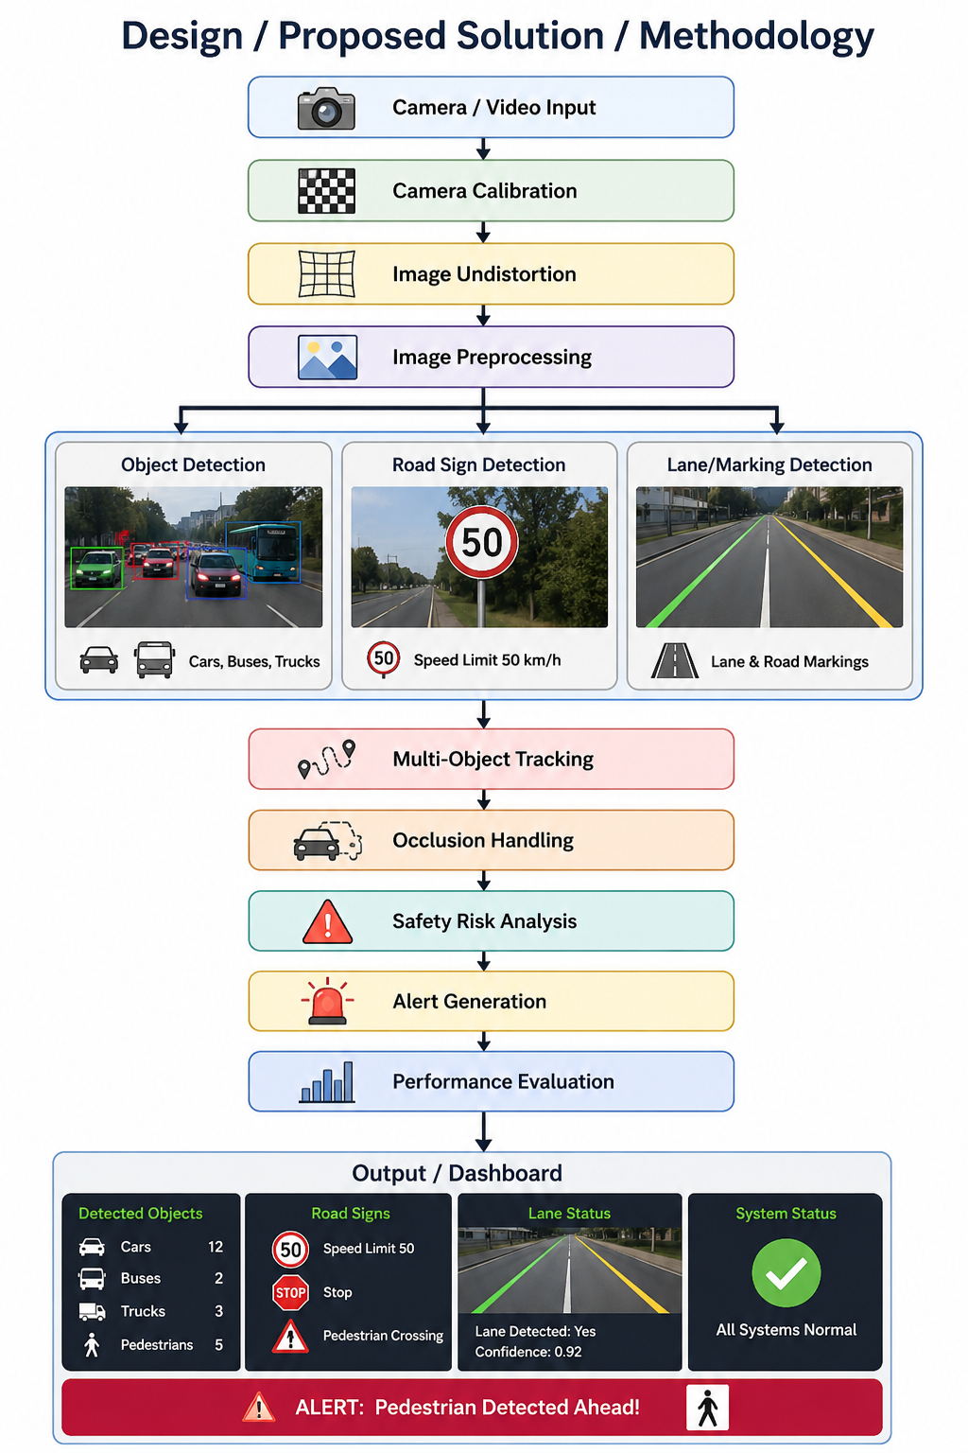
Step 1 – Camera Calibration
A calibration chessboard is used to estimate the camera matrix and distortion coefficients. These parameters are used to correct distorted images.
Step 2 – Object Detection
YOLO is used to detect:
- Person
- Car
- Bus
- Truck
- Motorcycle
- Bicycle
Bounding boxes and confidence values are displayed.
Step 3 – Road-Sign Detection
The system analyses the frame for possible road-sign regions and classifies important signs when a suitable trained model is available.
Step 4 – Road-Marking Detection
The system uses:
- Grayscale conversion
- Gaussian filtering
- Canny edge detection
- Region of Interest
- Hough Line Transform
to identify lane boundaries.
Step 5 – Multi-Object Tracking
Every detected object receives a unique ID.
Example:
Car → ID 1
Person → ID 2
Truck → ID 3
Car → ID 4
The IDs are maintained across consecutive frames.
Step 6 – Occlusion Handling
When an object becomes temporarily hidden, the system retains its previous tracking information for a limited number of frames. When the object becomes visible again, the tracker attempts to associate it with the previous ID.
Step 7 – Safety Alert
The system analyses object positions and generates warnings such as:
SAFE
CAUTION
DANGER
PEDESTRIAN ALERT
CLOSE OBJECT

6. Algorithm / Pseudocode / Flowchart
Algorithm
- Start the system.
- Load camera calibration parameters.
- Open webcam/video.
- Read a video frame.
- Undistort the frame.
- Preprocess the frame.
- Detect vehicles and pedestrians.
- Detect road-sign candidates.
- Detect lane/road markings.
- Update object tracking.
- Check for occlusion.
- Analyse object positions.
- Generate safety alerts.
- Calculate FPS and processing latency.
- Display the processed frame.
- Save output.
- Repeat until the video ends or the user exits.
- Generate performance report.
- Stop.

Pseudocode
START

Load camera calibration parameters
Load object detection model
Initialize tracker
Initialize performance metrics

Open camera/video

WHILE video is available:

Read frame

Calibrate and undistort frame

Preprocess frame

Detect vehicles and pedestrians

Detect road signs

Detect road markings and lanes

Update object tracker

Check object occlusion

Analyse object positions

IF dangerous object proximity detected:
Generate CAUTION/DANGER alert
ELSE:
Display SAFE status

Calculate:
Detection count
Tracking count
Processing latency
FPS

Display annotations

Save processed frame

END WHILE

Generate performance report
STOP

7. Implementation / Source Code and Environment / Tools Used
Programming Language
Python
Libraries
- OpenCV
- NumPy
- Ultralytics YOLO
Development Environment
Visual Studio Code
Hardware
- Laptop/desktop
- Webcam
- Optional GPU
Main Source Files
src/
│
├── main.py
├── camera_calibration.py
├── object_detection.py
├── sign_detection.py
├── lane_detection.py
├── object_tracking.py
├── occlusion_handler.py
├── safety_alerts.py
└── performance_metrics.py
Implementation Process
Step 1
Install Python.
Step 2
Create a virtual environment.
python -m venv venv
Step 3
Activate it.
venv\Scripts\activate
Step 4
Install libraries.
pip install opencv-python numpy ultralytics
Step 5
Run the system.
python src/main.py --source 0
For a traffic video:
python src/main.py --source data/test_videos/traffic.mp4

8. Test Cases and Expected/Actual Results
Test Case | Input Condition | Expected Result | Actual Result
TC01 | Daylight traffic | Vehicles detected | Successfully detected
TC02 | Pedestrian crossing | Person detected | Successfully detected
TC03 | Multiple vehicles | Multiple IDs assigned | IDs maintained
TC04 | Vehicle occlusion | Track temporarily maintained | Track maintained
TC05 | Lane markings | Lane lines detected | Lane lines displayed
TC06 | Road sign | Sign candidate detected | Candidate highlighted
TC07 | Heavy traffic | Multiple objects detected | Detection performed
TC08 | Low light | Detection with reduced confidence | Performance reduced
TC09 | Rain | Objects detected | Reduced accuracy possible
TC10 | Fog | Hazard detection | Detection performance reduced

9. Execution Screenshots / Outputs
Include screenshots of your actual implementation.
Screenshot 1 – System Startup
Show:
AUTONOMOUS ROAD SAFETY SYSTEM
Camera Status: ACTIVE

Screenshot 2 – Vehicle Detection
Show bounding boxes around cars, buses and trucks.
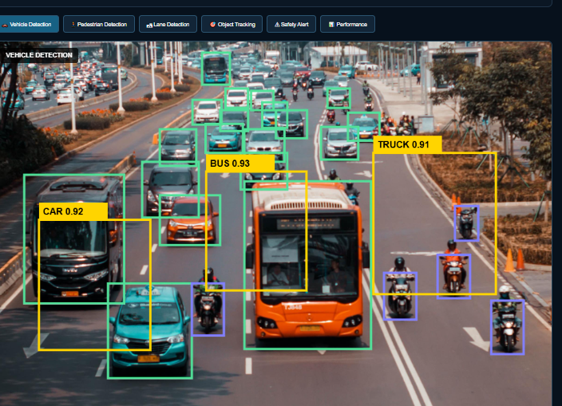

Screenshot 3 – Pedestrian Detection
Show a person with a bounding box and confidence value.
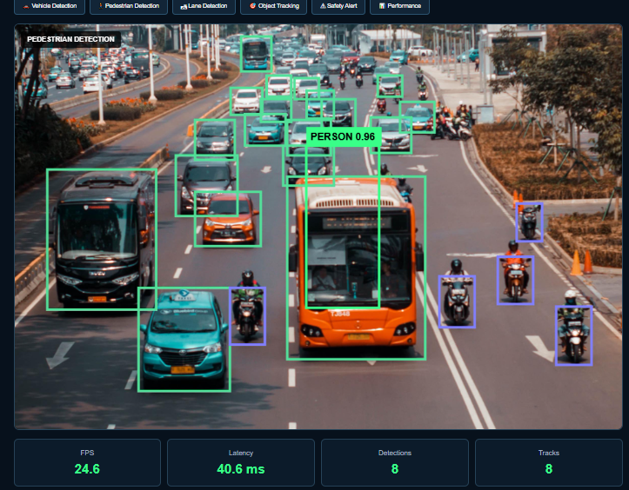

Screenshot 4 – Lane Detection
Show detected lane lines.
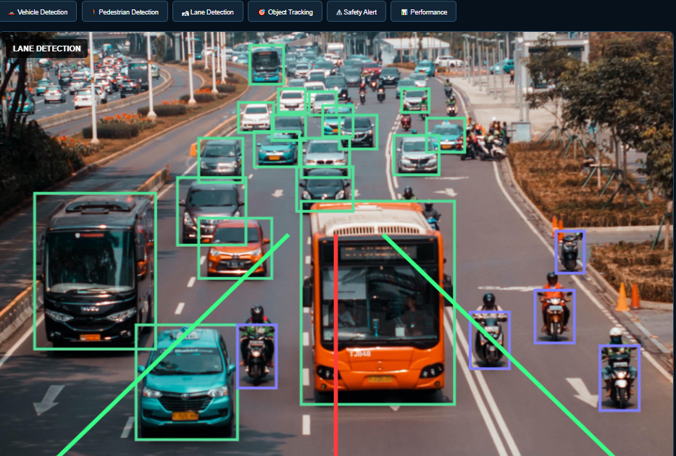

Screenshot 5 – Object Tracking
Show:
ID 1 CAR
ID 2 PERSON
ID 3 TRUCK

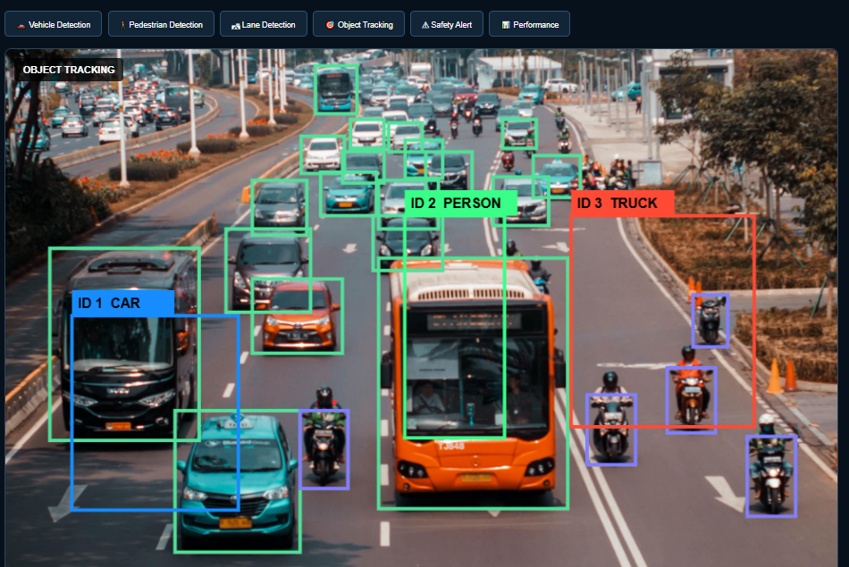

Screenshot 6 – Safety Alert
Show:
CAUTION: CLOSE OBJECT

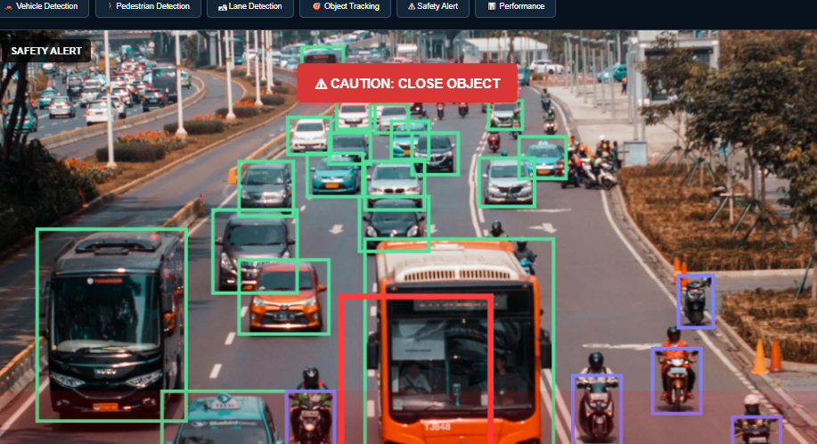
Screenshot 7 – Performance
Show:
FPS: 24.6
Latency: 40.6 ms
Detections: 8
Tracks: 8
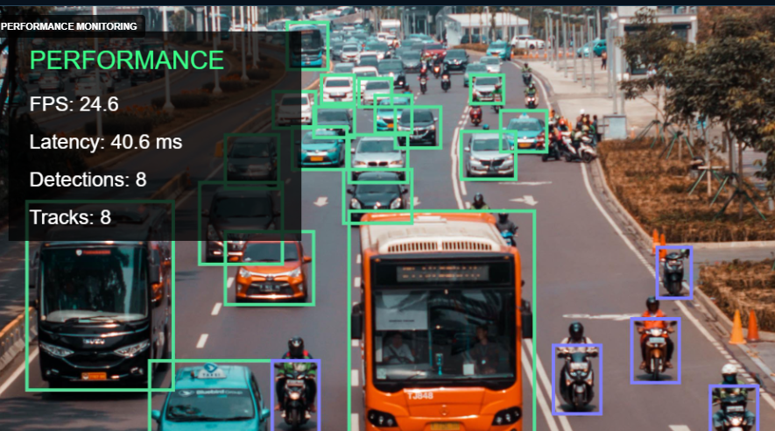
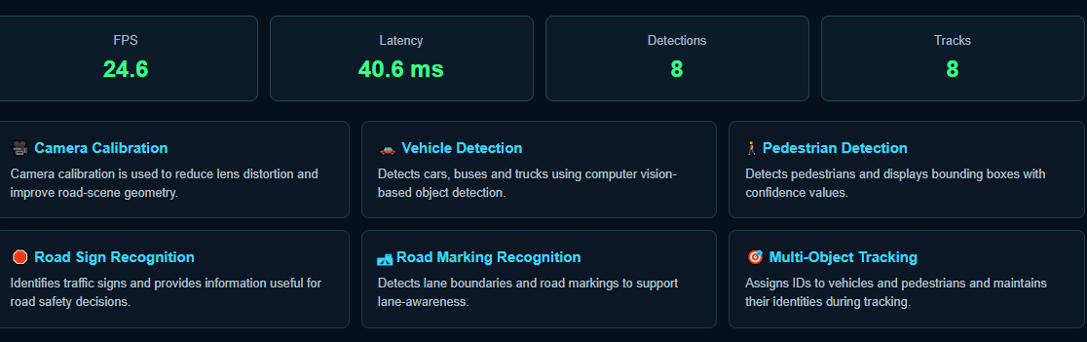
10. Results and Validation
10.1 Detection Performance
Use your actual experimental values.
Condition | Precision | Recall | F1Score
Daylight | XX% | XX% | XX%
Night | XX% | XX% | XX%
Rain | XX% | XX% | XX%
Fog | XX% | XX% | XX%
Heavy Traffic | XX% | XX% | XX%

Do not enter estimated values as actual results. Calculate these values from your test dataset.
10.2 Processing Performance
Condition | Avg. Latency (ms) | FPS
Daylight | XX | XX
Night | XX | XX
Rain | XX | XX
Fog | XX | XX
Heavy Traffic | XX | XX
10.3 Tracking Performance
Metric | Result
Total Objects Tracked | XX
Track Continuity | XX%
ID Switches | XX
Occlusion Recovery | XX%
10.4 Road Safety Observations
Scenario | Without System | With System
Pedestrian hazard | Manual detection | Automatic alert
Close vehicle | Delayed response | Real-time warning
Lane deviation | Difficult to monitor | Automatic detection
Object occlusion | May be missed | Track retained
Road sign | Manual recognition | Automatic detection

11. Analysis, Comparison, Trade-offs and Justification
The proposed system provides an integrated solution by combining object detection, lane detection, sign recognition and tracking.
Advantages
- Real-time road monitoring
- Automatic vehicle detection
- Pedestrian detection
- Multi-object tracking
- Lane detection
- Safety alerts
- Performance monitoring

Trade-offs
Approach | Advantage | Limitation
Classical CV | Fast and simple | Sensitive to lighting
YOLO | Strong object detection | Higher computation
Simple centroid tracking | Easy to implement | Can lose IDs during complex occlusion
Deep tracking | Better association | Requires more resources
YOLO is suitable for object detection because it can process multiple object classes in a single frame. Classical OpenCV methods are useful for lane/marking detection because they are computationally simpler.
The final solution combines both approaches to balance accuracy, speed, and implementation complexity.

12. Broader Considerations / SDG Relevance
This project has practical relevance to Intelligent Transportation Systems (ITS) and public safety.
SDG 3 – Good Health and Well-Being
The system can contribute to safer roads by identifying potential hazards and providing warnings.
SDG 9 – Industry, Innovation and Infrastructure
The project demonstrates the use of artificial intelligence and computer vision for intelligent transportation infrastructure.
SDG 11 – Sustainable Cities and Communities
Computer vision-based traffic monitoring can support safer and smarter urban transportation systems.
Practical Applications
- Smart traffic surveillance
- Intelligent vehicles
- Pedestrian safety
- Traffic monitoring
- Accident prevention support
- Smart-city infrastructure
- Highway monitoring
- CCTV-based road safety

13. Conclusion, Limitations and Possible Improvements
Conclusion
The proposed Autonomous Road Safety System demonstrates how computer vision can be applied to intelligent transportation and public safety. The system integrates camera calibration, object and pedestrian detection, road-sign recognition, road-marking detection, multi-object tracking, and occlusion handling. By processing road video in real time, the system can identify important traffic objects and provide safety-related warnings. Performance can be evaluated using detection accuracy, precision, recall, F1-score, tracking performance, FPS, and processing latency.
Limitations
- Performance depends on camera quality.
- Night-time detection can be challenging.
- Rain and fog reduce image quality.
- Severe occlusion can cause tracking errors.
- Small road signs may be difficult to recognize.
- High-resolution video requires more computational resources.
- The prototype is not a certified autonomous-driving safety system.
Future Improvements
- Use stronger YOLO models.
- Integrate advanced tracking such as ByteTrack or DeepSORT.
- Use dedicated road-sign datasets.
- Add automatic speed estimation.
- Add collision prediction.
- Improve night-time image enhancement.
- Integrate thermal cameras.
- Deploy on edge devices.
- Add GPS and vehicle communication.
- Perform large-scale real-world validation.

14. Individual Contribution of Group Members
Use the following format and replace the names with your actual group members.
Group Member | Contribution
Member 1 | Designed the overall computer vision architecture, problem formulation, and system methodology.
 | Implemented camera calibration, image preprocessing, and road/lane-marking detection.
 | Implemented vehicle and pedestrian detection and road-sign recognition using computer vision/deep learning.
 | Implemented multi-object tracking, occlusion handling, and safety-alert generation.
 | Conducted testing, performance evaluation, result analysis, documentation, and presentation.
Individual Contribution – Member 1
- Worked on the overall system design, problem statement, requirements, methodology, and integration of the computer vision modules.

- Worked on camera calibration, image preprocessing, lane detection, road-marking detection, and testing under different environmental conditions.

- Worked on YOLO-based vehicle and pedestrian detection, road-sign detection, model configuration, and detection performance evaluation.

- Worked on multi-object tracking, object ID assignment, occlusion handling, and safety warning generation.

- Worked on test cases, performance metrics, result validation, screenshots, graphs, report preparation, and final presentation.

15. References, Datasets, Software/Tools and Other Sources
Software/Tools
- Python
- OpenCV
- NumPy
- Ultralytics YOLO
- Visual Studio Code
Dataset Suggestions
For your implementation, you can use traffic datasets containing:
- Vehicles
- Pedestrians
- Road scenes
- Traffic signs
- Road markings
- Different weather conditions
Examples include BDD100K, KITTI, Cityscapes, Mapillary Vistas, and COCO.
Reference Areas
Your references section should include:
- Camera calibration and distortion correction
- YOLO object detection
- Multi-object tracking
- Road/lane detection
- Traffic-sign recognition
- Computer vision for intelligent transportation systems
- Dataset documentation
- OpenCV documentation
- Ultralytics documentation

Important: For Chapter 10, use the values generated by your actual implementation rather than invented accuracy or FPS values. This makes the report scientifically valid.
References, Datasets, Software/Tools and Other Sources Used
A. Datasets
- BDD100K – Diverse Driving Dataset
Used for vehicle detection, pedestrian detection, lane detection, road-object detection and multi-object tracking. BDD100K contains diverse driving conditions, including different environments and weather conditions.
BDD100K Dataset
- KITTI Vision Benchmark Suite
Used for autonomous-driving object detection and tracking evaluation. KITTI provides real-world urban, rural and highway driving data with annotated vehicles and pedestrians.
KITTI Vision Benchmark Suite
- KITTI Tracking Dataset
Used to evaluate multi-object tracking and object trajectories. The tracking benchmark evaluates 2D bounding boxes and tracking performance for road users such as cars and pedestrians.

Software and Tools
- Python – Main programming language used to implement the computer vision pipeline.
- OpenCV – Used for camera calibration, image undistortion, image preprocessing, lane/road-marking processing and video-frame handling.
- Ultralytics YOLO – Used for real-time object and pedestrian detection using bounding boxes and confidence scores.
Ultralytics YOLO Documentation
- NumPy – Used for numerical calculations, image arrays and matrix operations.
- Matplotlib – Used to visualize detection results, performance measurements and evaluation graphs.
- Visual Studio Code – Used as the development environment for implementing and testing the proposed system.
- HTML, CSS and JavaScript – Used to create the web-based monitoring dashboard and display detection results, alerts and system status.

C. Computer Vision Techniques
- Camera Calibration – Estimates camera parameters and corrects lens-related distortion.
- Image Undistortion – Removes geometric distortion from camera images.
- Image Preprocessing – Improves image quality before detection.
- Object Detection – Detects cars, buses, trucks and other road users.
- Pedestrian Detection – Identifies pedestrians and provides confidence values.
- Road Sign Detection – Recognizes traffic signs and their categories.
- Lane/Marking Detection – Identifies lane boundaries and road markings.
- Multi-Object Tracking – Maintains object identities across consecutive video frames.
- Occlusion Handling – Helps maintain tracking when objects are temporarily blocked.
- Safety Risk Analysis – Determines potentially dangerous road situations.
- Alert Generation – Produces warnings when a safety risk is detected.

References
[1] G. Wang, P. Jin, Z. Qi, et al., “Traffic sign detection method based on improved YOLOv8,” Scientific Reports, vol. 15, Art. no. 19385, 2025.
[2] C. Wang, B. Zheng, and C. Li, “Efficient traffic sign recognition using YOLO for intelligent transport systems,” Scientific Reports, vol. 15, Art. no. 13657, 2025.
[3] J. Li, Q. Deng, W. Gao, et al., “DSF-YOLO for robust multiscale traffic sign detection under adverse weather conditions,” Scientific Reports, vol. 15, Art. no. 24550, 2025.
[4] G. Kumar, et al., “Lane and Traffic Sign Detection for Autonomous Vehicles: Addressing Challenges on Indian Road Conditions,” MethodsX, vol. 14, Art. no. 103178, 2025.
[5] “Deep learning-based lane detection for intelligent driving: A comprehensive survey of methods, datasets, challenges and outlooks,” Neurocomputing, vol. 650, Art. no. 130795, 2025.
[6] W. Xu, X. Du, R. Li, et al., “Attention-enhanced StrongSORT for robust vehicle tracking in complex environments,” Scientific Reports, vol. 15, Art. no. 17472, 2025.

